Bad designs: <lingscars.com>

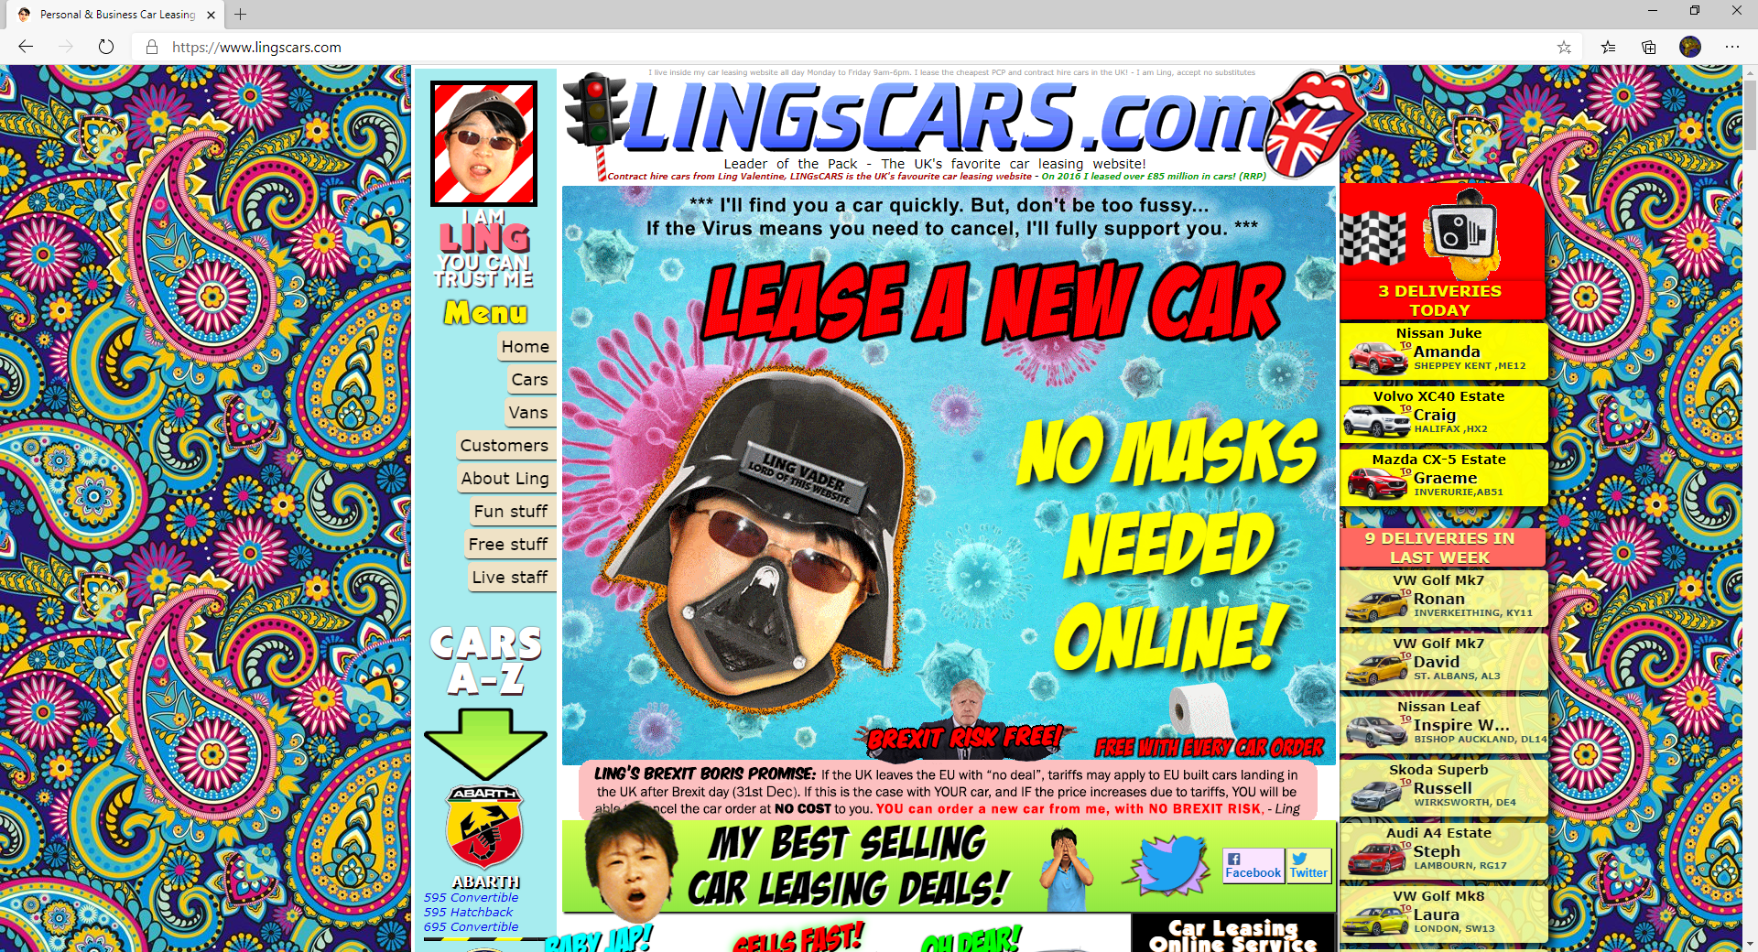

Bad stuff:

* Too much stuff!
* Unprofessional
* Must I say more
* Long Load time

Good stuff:

* Nothing

<http://industrialpainter.com/f/painting-contractor.html>

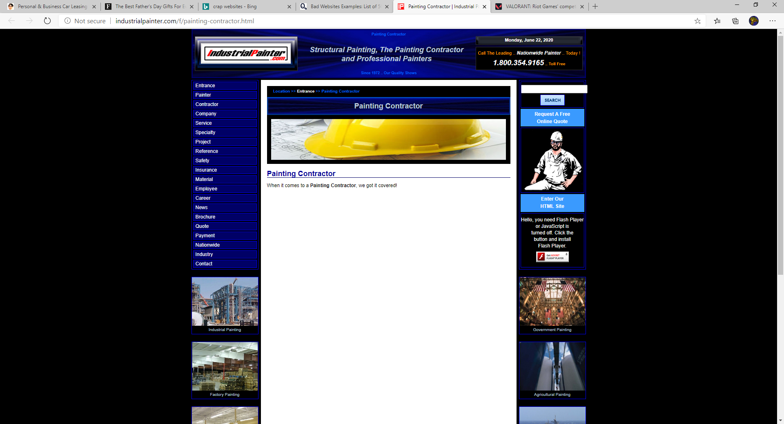

Bad stuff:

* More than half the screen is black or white
* Some parts need adobe flash
* The cap image is super short

<http://www.gatesnfences.com/>

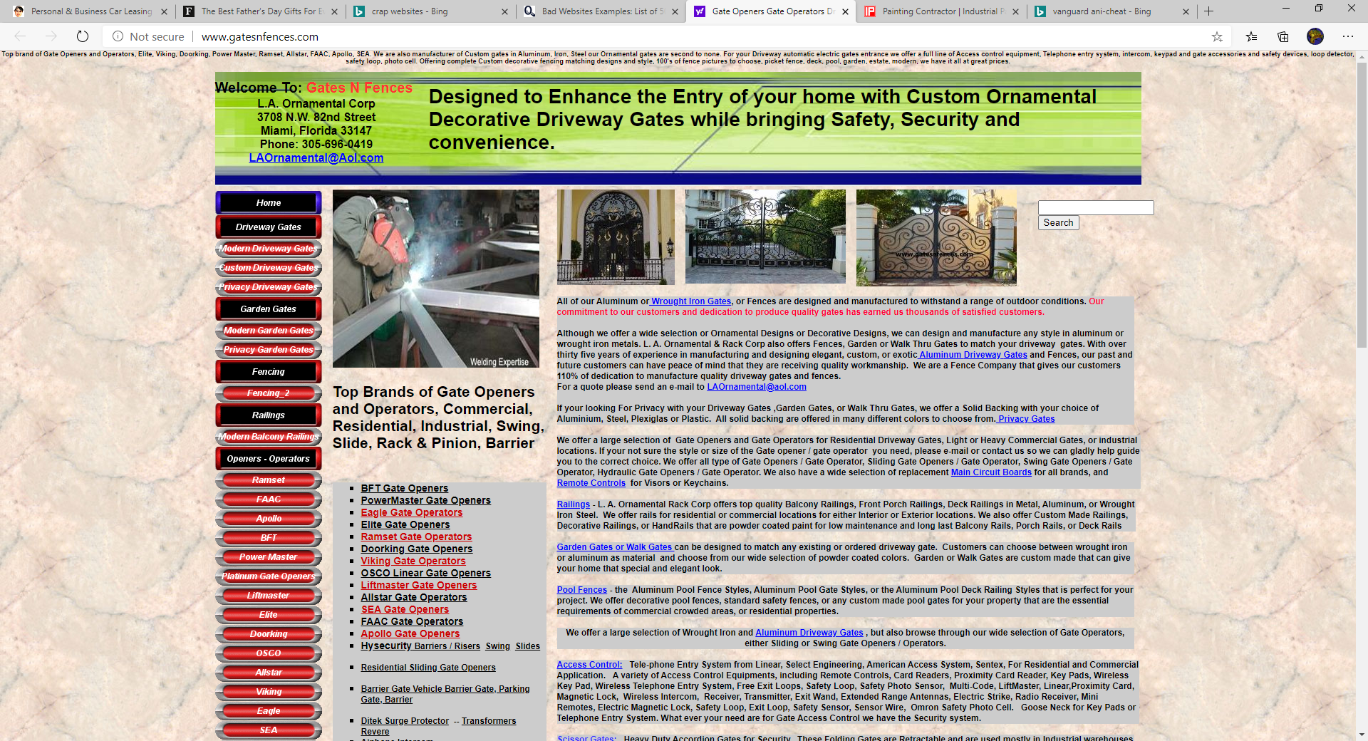

* Lots of hard to read text
* No organisation